## **Codility output screenshots (Senadhian G):**

Program 1 :[Codility Result Link](https://app.codility.com/demo/results/trainingFZXBKT-P8A/)

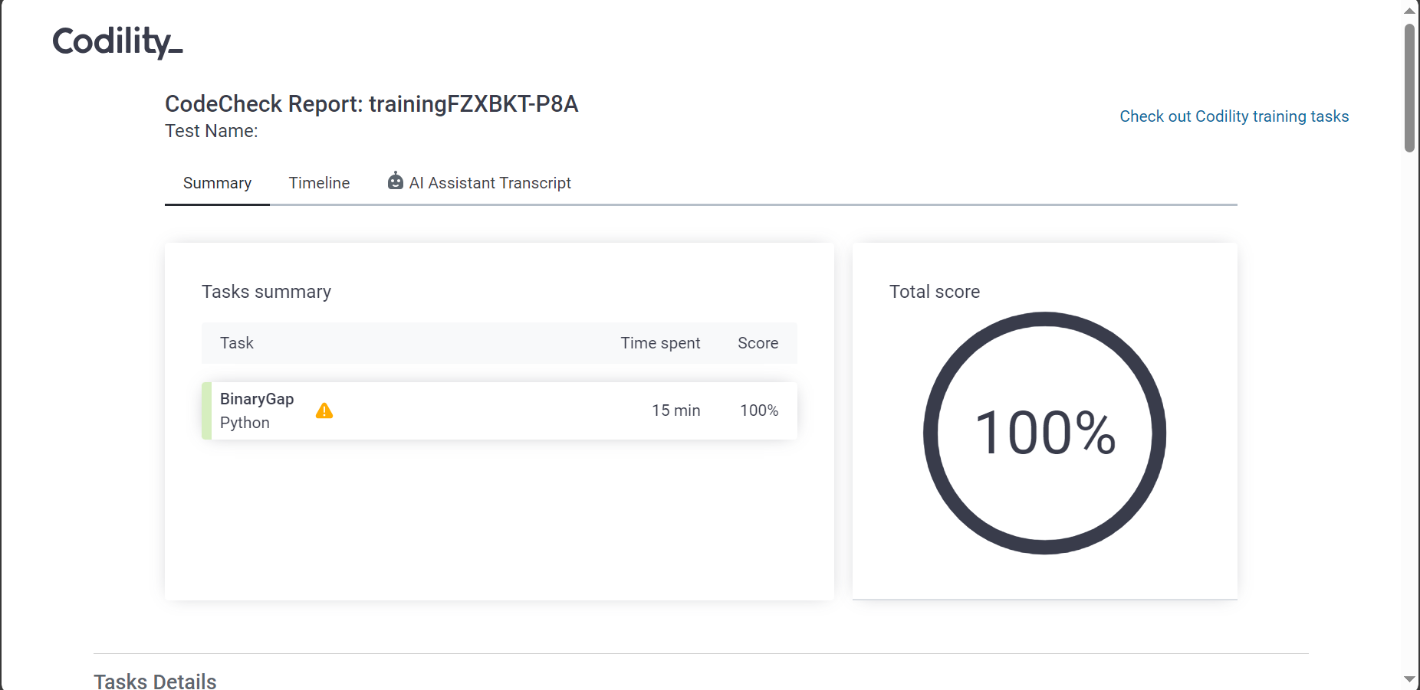

Program 2.1 : [Codility Result Link](https://app.codility.com/demo/results/trainingX98XU6-U7N/)

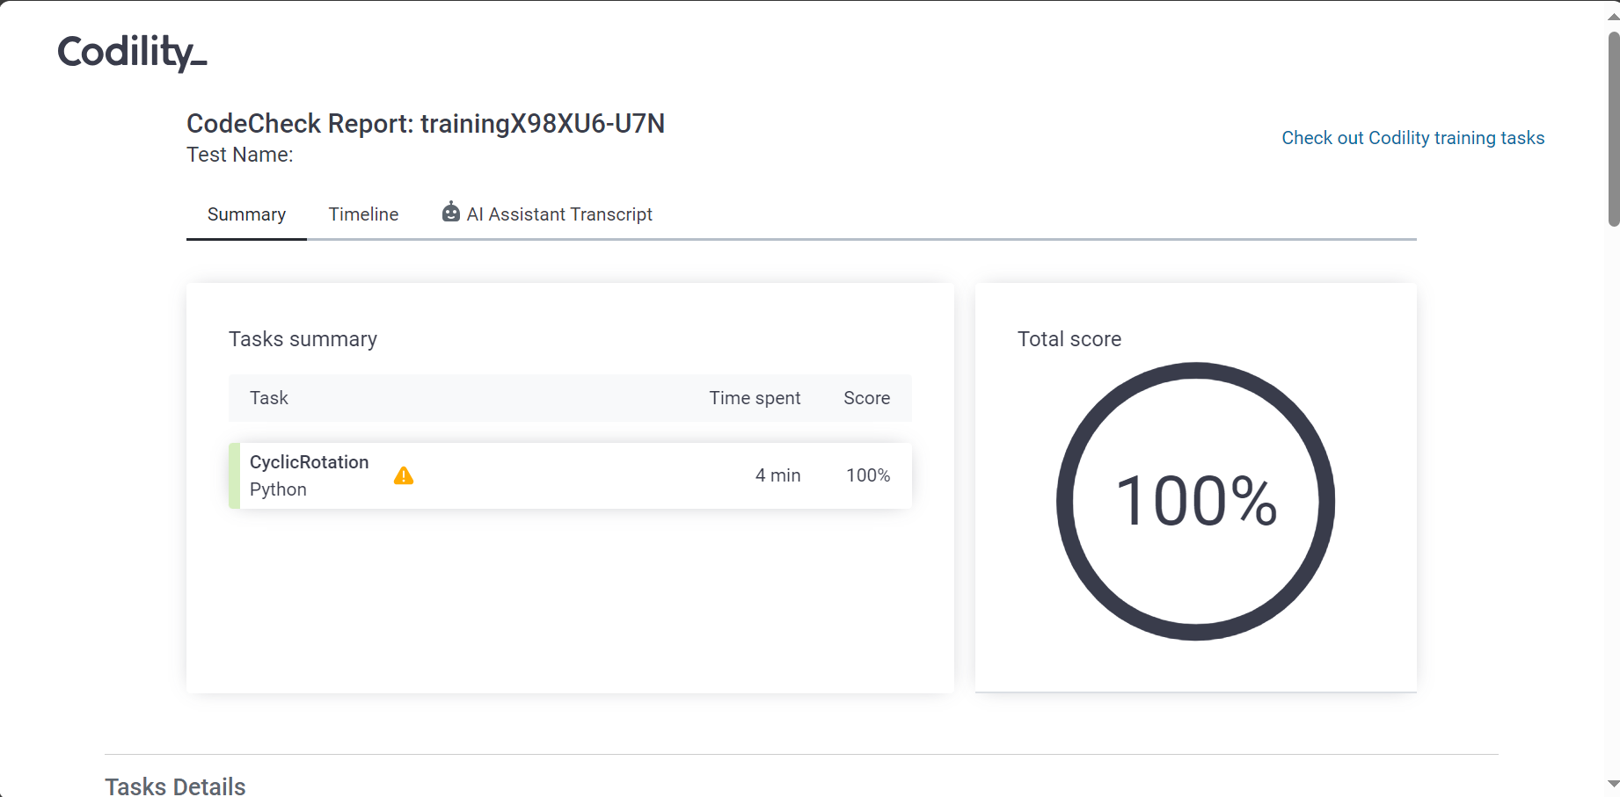

Program 2.2 : [Test results - Codility](https://app.codility.com/demo/results/trainingJT4UQP-KV7/)

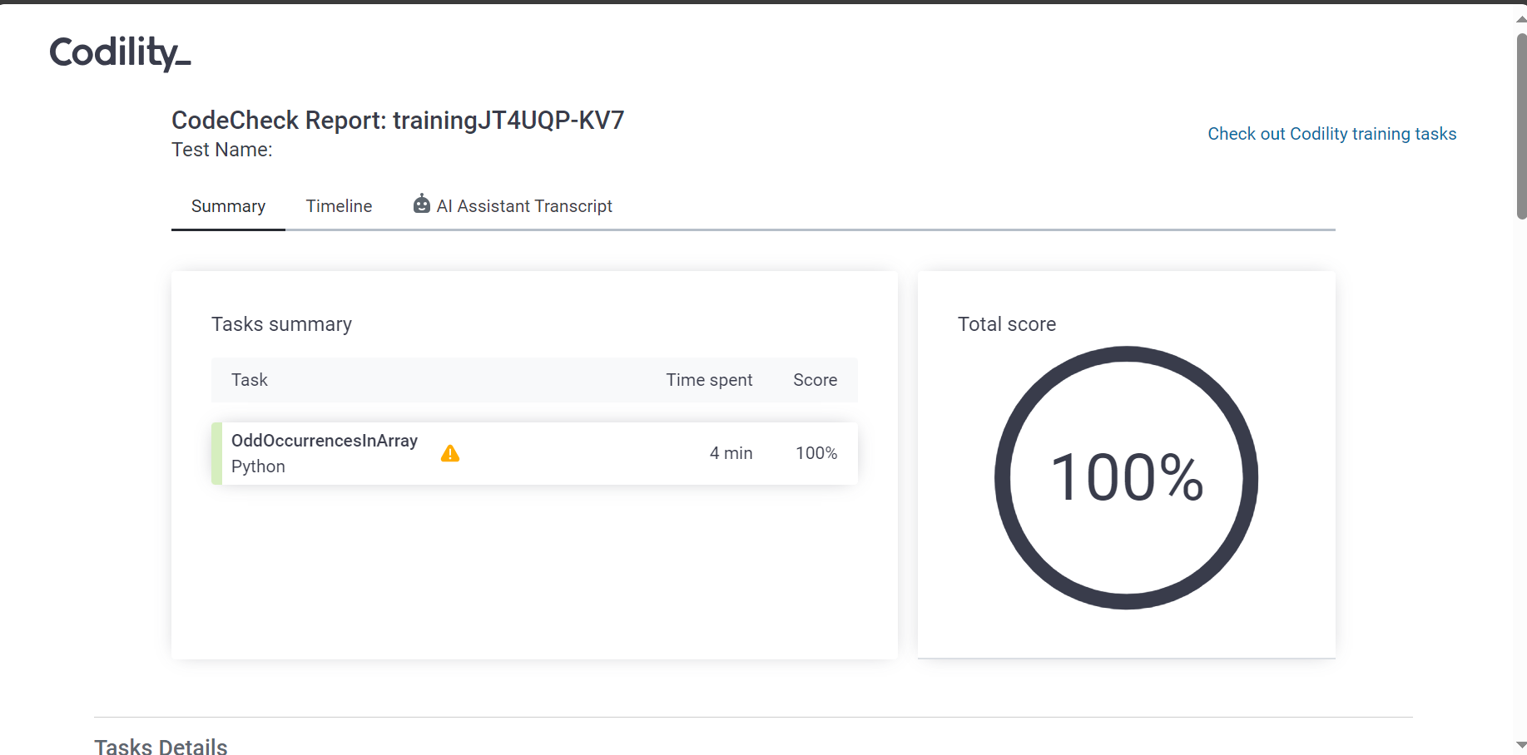

Program 3.1 : [Test results - Codility](https://app.codility.com/demo/results/trainingGH7PVK-7HE/)

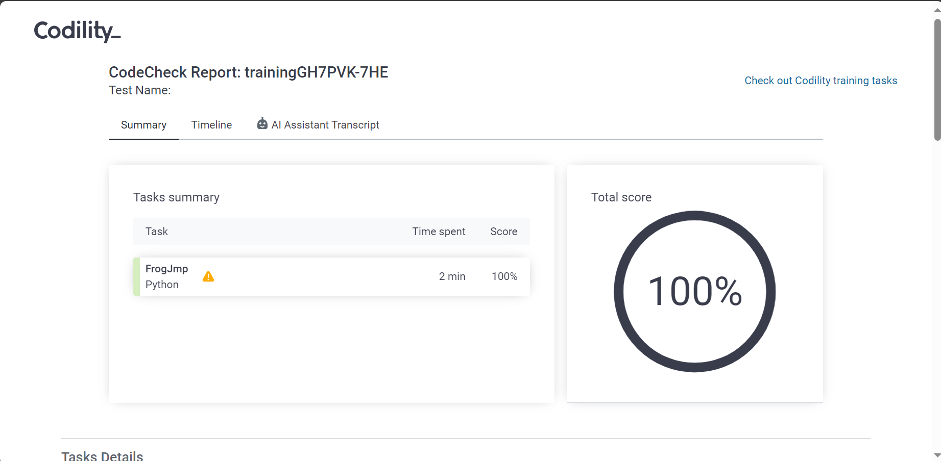

Program 3.2 : [Test results - Codility](https://app.codility.com/demo/results/trainingXG6J98-A5K/)

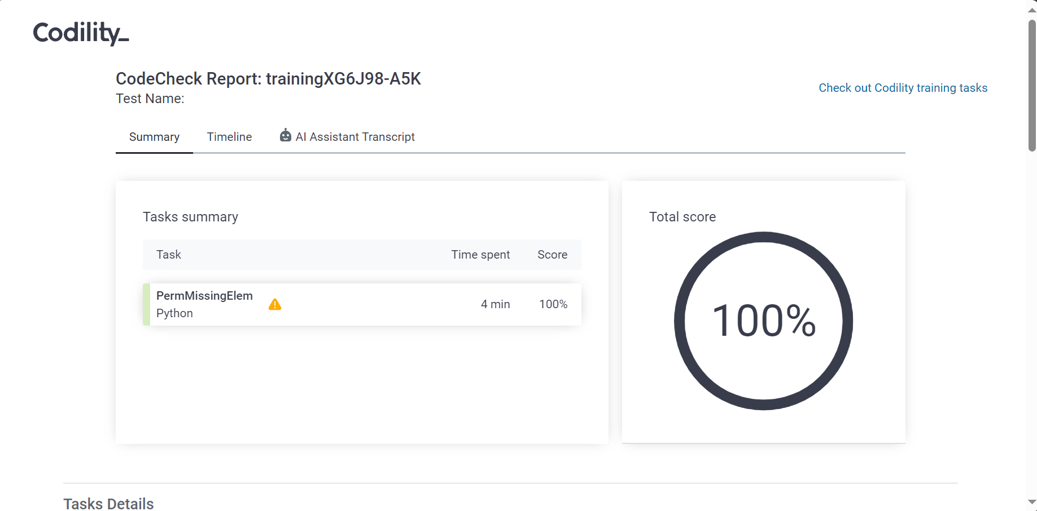

Program 3.3 : [Test results - Codility](https://app.codility.com/demo/results/trainingUYS7ZD-A95/)

